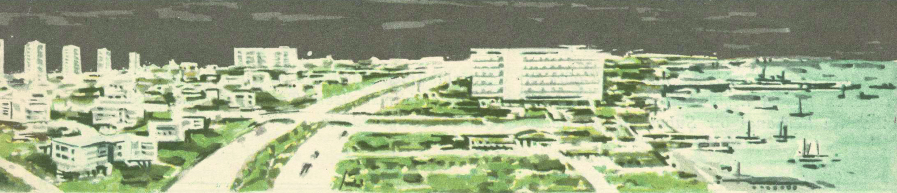

Ist International DOCOMOMO Workshop
“How to Preserve a Housing Utopia:
The Documentation and Sustainability of Modern Heritage,
Case Study: Ataköy – Istanbul”
Istanbul – Turkey, September 18-26, 2006

DOCOMOMO_Turkey is hosting the Ist International DOCOMOMO Workshop in connection with the IXth International DOCOMOMO Conference, to be organized in Ataköy – Istanbul on September 18-26, 2006 prior to the main event. DOCOMOMO International feels the need to combine theory and practice on a case study with the participation of different generations of researchers in the field.
The study area is one of İstanbul’s first suburban mass housing zones and theme has been defined as “How to Preserve a Housing Utopia: The Documentation and Sustainability of Modern Heritage, Case Study: Ataköy – Istanbul”. Ataköy is selected for its urban and architectural features and because of the need for re-evaluating these features as part of the Modern Movement heritage. The initial steps of this project, Phases I and II are today iconic examples of urban planning and architecture of the late 1950s and 1960s. The sustainability of this area is of great importance at the moment and this should be the main criterion for conservation proposals.
Participants including members of the DOCOMOMO International Specialist Committees (ICSs) on Registers, Technology, Urbanism + Landscape and Theory + Education and graduate students and academicians of various related disciplines are asked to study and evaluate this settlement area in relation to documentation and conservation issues. The organization committee formed of representatives from five institutions in Turkey including Dokuz Eylül University, İstanbul Technical University, Middle East Technical University, Mimar Sinan Fine Arts University and Yıldız Technical University invited 30 tutors/lecturers and 60 graduate students from 16 institutions all over the world. The aim is to learn from each other’s experiences and develop new proposals for sustainability. The documents produced by the workshop participants, which will form an introduction for developing strategies for the conservation of the Modern Movement heritage in Turkey, will be presented and discussed during the conference in Ankara as well.

The image is taken from a sales leaflet printed by Türkiye Emlak Kredi Bankası A.O. in the 1950s.

